Title of Contribution

Presenting Author¹, Second Author², Other Authors^{1,2}

¹Department, University/Institute, City, Country
²Department, University/Institute, City, Country

The body of the abstract should start on this line and should be clearly written, self-contained and, when possible, abbreviations and complicated equations will be avoided. The abstract will be limited to a single page. The text will be justified and written using 14pt Times New Roman fonts with single line pacing. A figure may be added between the main text of the abstract and the references. A single line will separate the figure from the main text of the abstract and another one the caption from the bibliography. Please refrain from using headers or footnotes and/or modifying the format of this file. References [1] will use square brackets [1,2].

The file will be saved in .docx format, named following the convention “familyname_firstname_oral.docx” and “familyname_firstname_poster.docx” and uploaded to the registration form. You may also upload pdf files of the abstract. Soon after the deadline for abstract submission, you will receive confirmation of the acceptance of your contribution as an oral or poster presentation.

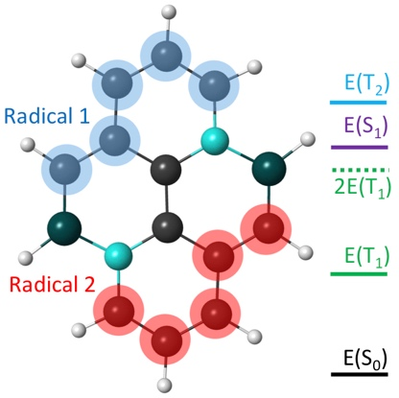
Figure caption: Two radical fragments in our substituted pyrene.

[1] F. Author; S. Author; Journal Volume FirstPage (Year)
[2] F. Author, et al.: Book Title (Publishing Company, Place, Year) 230-235.

